Project Report on Banking Analytics Dashboard

Dashboard:
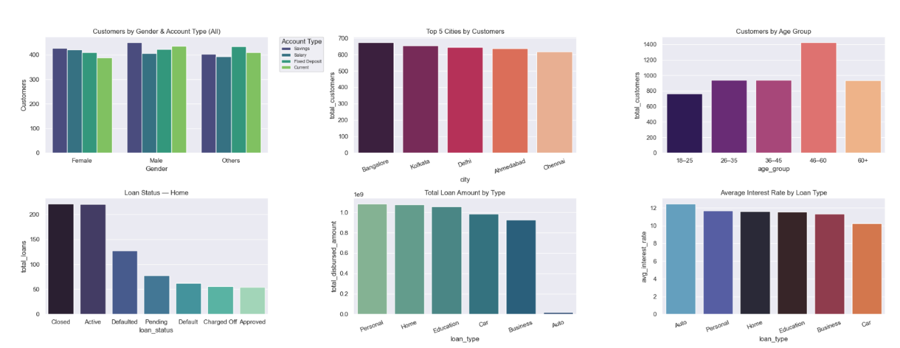

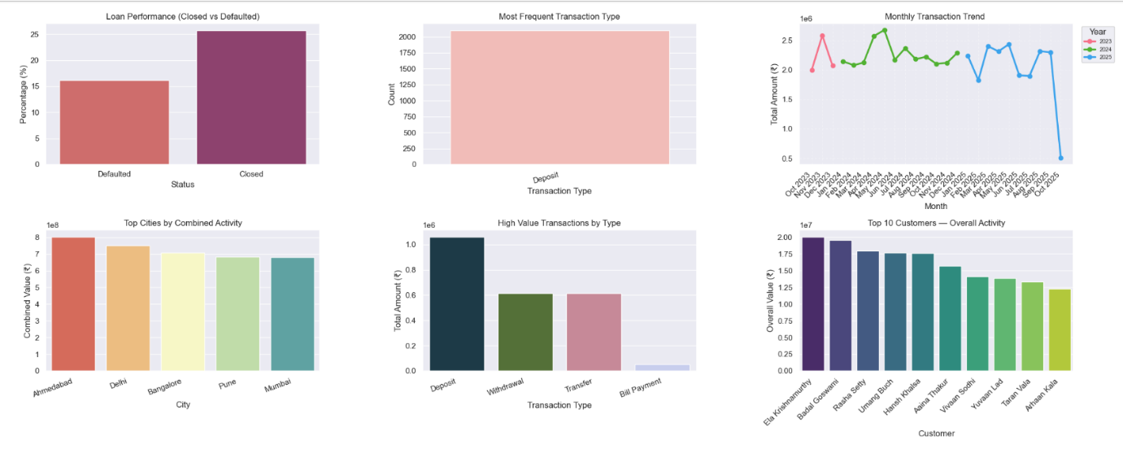

Project Title:
Intelligent Banking Analytics System Using Python and MySQL
Submitted By: KODAVALLURI DINESH SAI
Date: [DD/MM/YYYY]
Batch: Data Analytics Batch 3
Tools Used: MySQL, Python, Pandas, Numpy, Matplotlib, Seaborn

1. Project Objective
The objective of this project is to design and develop an end-to-end Banking Analytics Dashboard using MySQL, Python, Pandas, Matplotlib, and Seaborn to provide comprehensive insights into:
- Customer demographics and income distribution
- Loan types, disbursed amount, interest rates, and performance
- Transaction patterns, trends, and high-value movements
- Combined financial activity across customers and cities
By integrating SQL stored procedures, Pandas-based data cleaning, and Python-based visualizations, the project aims to:
- Automate banking reports and reduce manual analysis
- Help stakeholders understand who the customers are, how loans are performing, and how money flows via transactions
- Support data-driven decisions in areas like credit risk, marketing, and customer management

2. Data Sources
Database Name: Banking
Tables Used:
- customers
  - Columns (example):
customer_id, first_name, last_name, full_name, gender, dob, age, city, state, occupation, income, account_type, account_open_date, account_age, balance, credit score, loan_status.
- loans
  - Columns (example):
loan_id, customer_id, loan_type, loan_amount, interest_rate, tenure_months, start_date, end_date, status.
- transactions
  - Columns (example):
transaction_id, customer_id, transaction_date, year, month, day_of_week, hour, transaction_type, transaction_category, transaction_mode, merchant, amount, status_transaction.
Data Source Type:
- Imported from CSV files into Pandas DataFrames
- Cleaned in Python and then loaded into MySQL tables

3. Data Cleaning & Transformation (Using Pandas in Python)
Data cleaning was done using Pandas before loading into MySQL to ensure high-quality, consistent data.
Steps taken:
- Importing Data
  - Loaded CSVs into Pandas DataFrames using pd.read_csv()
  - Separate DataFrames for customers, loans, and transactions
- Handling Missing Values
  - Used df.isnull().sum() to inspect nulls
  - For critical columns (IDs, dates), dropped rows with missing values using df.dropna()
  - For numeric fields like income, loan_amount, amount, used fillna() or domain logic (e.g., median/mean imputation)
- Standardizing Data Types
  - Converted date columns to datetime using pd.to_datetime()
  - Ensured numeric fields (income, amount, loan_amount, interest_rate) are of appropriate numeric type (int, float) using .astype()
- Removing Duplicates
  - Applied df.drop_duplicates() on key combinations (e.g., unique customer_id, loan_id, transaction_id)
- Normalizing Categorical Fields
  - Standardized values like gender, account_type, loan_type, status, transaction_type using string operations (.str.lower(), .str.strip(), .replace())
- Creating Derived Columns
  - Age Group from age using pd.cut() (e.g., 18–25, 26–35, 36–45, 46–60, 60+)
  - Month / Year from transaction_date using .dt.to_period('M') or .dt.strftime('%Y-%m')
  - Any other feature engineering as required (e.g., is_high_value_transaction)
- Exporting to MySQL
  - After cleaning, used either:
    - to_sql() via SQLAlchemy, or
    - Iterative inserts via mysql.connector
  - Populated customers, loans, and transactions tables in the Banking database

4. Data Modeling (Database Design)
Primary Keys:
- customers.customer_id
- loans.loan_id
- transactions.transaction_id
Foreign Keys:
- loans.customer_id → customers.customer_id
- transactions.customer_id → customers.customer_id
Relationships:
- One customer → Many loans
- One customer → Many transactions
This relational model enables combined analysis across the three tables (e.g., customer income vs. loan performance vs. transaction patterns).
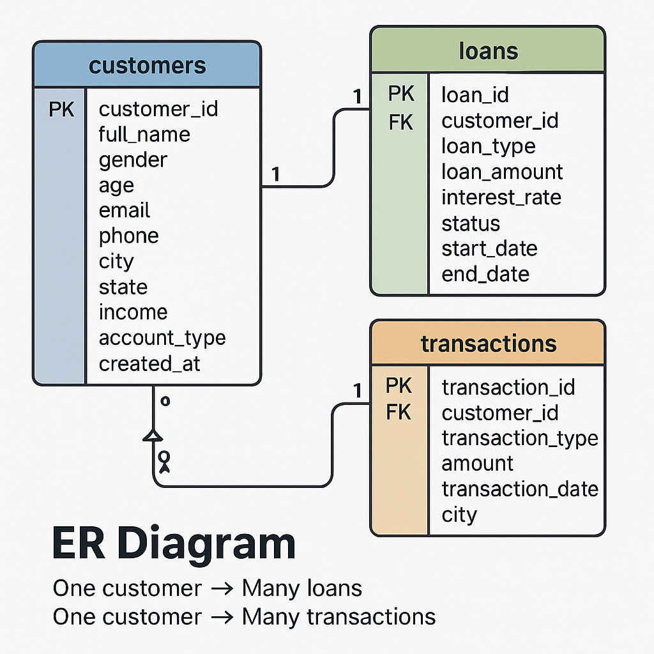

5. Stored Procedures & SQL Logic (MySQL)
To make the analysis reusable and efficient, multiple stored procedures were created in MySQL. Below are the main categories.
5.1 Customer Analysis Procedures
- total_customers_by_gender_account(IN acc_type, OUT total_count)
  - Finds number of customers by gender and account type
  - Optionally filters by a specific account type (e.g., 'Savings')
- high_income_customers(IN P_income)
  - Lists customers with income > P_income
  - Used to identify premium or high-value customers
- customers_by_age_group()
  - Groups customers into predefined age ranges
  - Returns each age_group with total customers
- top_5_locations()
  - Finds top 5 cities by customer count
- most_popular_account_type()
  - Returns account type with maximum customers

5.2 Loan Analysis Procedures
- count_loans_by_status(IN loan_type_filter, OUT total_loans_count)
  - Shows loan counts by status (Approved, Closed, Defaulted, Pending etc.) for a specific loan type
- total_loan_amount_by_type()
  - Sums loan_amount for each loan_type
- avg_interest_rate_by_type()
  - Calculates average interest rate per loan type
- customers_with_multiple_loans()
  - Identifies customers having more than one loan
- loan_performance_summary()
  - Shows percentage of loans Closed vs Defaulted

5.3 Transaction Analysis Procedures
- total_avg_transaction_per_customer(IN months_interval, OUT overall_avg)
  - For the last N months, shows each customer’s total and average transaction amount
- top_10_customers_last6months()
  - Top 10 customers by transaction count and amount in the last 6 months
- most_frequent_transaction_type()
  - Which transaction type occurs most (Deposit, Withdrawal, Transfer, etc.)
- monthly_transaction_trends()
  - Monthly total transaction amount and count
- high_value_transactions()
  - Lists transactions with amount > 50000, with customer details

5.4 Combined Analytics Procedures
- topn_customers_activity(IN top_n)
  - Combines total transaction amount + total loan amount to rank customers by overall value
- active_loan_recent_transactions(IN status, OUT active_count)
  - Customers with a particular loan status (e.g., 'Active') AND recent transactions
- top_cities_by_financial_activity()
  - Sum of loan_amount + transaction amount by city
- inactive_loan_customers(IN months_interval)
  - Customers having loans but no transactions for the last N months
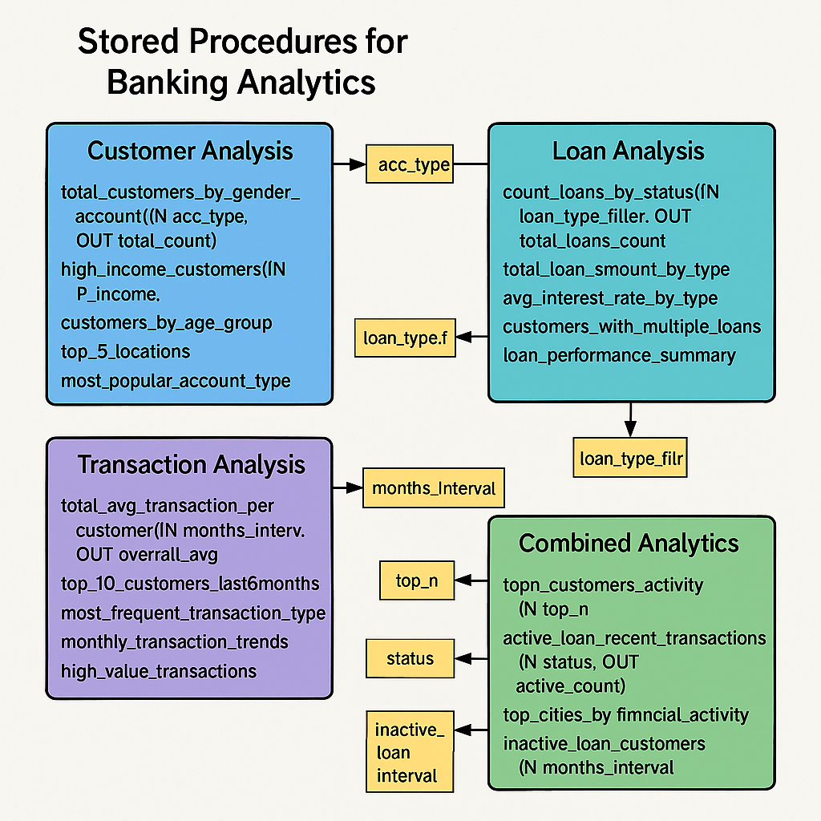

6. Python Integration & Analytics
Key Libraries Used:
- mysql.connector – Connect Python to MySQL
- pandas – DataFrames, transformations
- matplotlib.pyplot & seaborn – Visualizations
Steps:
- Define db_config (host, user, password, database)
- Create a reusable run_proc(proc_name, params) function:
  - Calls stored procedures
  - Fetches results via cursor.stored_results()
  - Converts them into Pandas DataFrames
- Use dedicated visualization functions for each analysis:
  - Bar charts for counts & totals
  - Line charts for trends
  - Pie charts for percentage distributions
- Add menus or user input to:
  - Choose loan type, account type, months interval, top N etc.
  - Dynamically update charts based on user choices

7. Dashboard Visualizations
The final dashboard is designed using Matplotlib subplots and Seaborn with different color palettes.
Visuals Included:
- Total Customers by Gender & Account Type
- Customers by Age Group
- Top 5 Locations (Cities) by Customer Count
- High Income Customers (Bar chart by Income)
- Loan Count by Status (for selected loan type)
- Total Loan Amount by Loan Type
- Average Interest Rate per Loan Type
- Loan Performance Summary (Closed vs Defaulted)
- Monthly Transaction Trends (Line chart by month)
- Most Frequent Transaction Type
- High-Value Transactions by Type or Customer
- Top N Customers by Overall Activity (Loans + Transactions)

8. Filters, Inputs & User Interaction
The Python scripts allow interaction via:
- Account Type Input (e.g., “Savings”, “Current”)
- Loan Type Input (e.g., “Home”, “Car”, “Business”)
- Months Interval for transaction-based queries
- Top N customers for ranking
- Loan Status Filter (Active, Closed, Defaulted, Pending)
This makes the dashboard flexible and user-driven instead of static.

9. Project Workflow (Step-by-Step)
- Import raw banking data into Pandas DataFrames
- Clean and preprocess data using Pandas
- Load cleaned data into MySQL tables
- Create stored procedures for customer, loan, transaction, and combined analytics
- Connect Python to MySQL using mysql.connector
- Execute stored procedures and store results in Pandas DataFrames
- Visualize the outputs using Matplotlib and Seaborn in subplot dashboards
- Apply user filters to re-run queries and update visualizations
- Interpret insights and document findings (KPIs, patterns, risk areas, opportunities)

10. Key Insights from the Banking Analytics Dashboard
- The 46–60 age group forms the majority of customers
- Savings accounts are the most popular account type
- Home loans and Business loans dominate total loan amounts
- Auto loans have relatively higher interest rates
- Most transactions are Deposits and Withdrawals
- High-value transactions (> ₹50,000) are mostly from major cities
- Loan closure rate is higher than default rate, indicating good performance
- A small % of customers hold multiple loans, contributing significantly to revenue
- Top 5 cities contribute a large share of total banking value (loans + transactions)
- Some customers have loans but no recent transactions — potential at-risk or inactive customers

11. Analysis Questions (For Presentation & Evaluation)
11.1 Customer Analysis
- How many customers do we have by gender and account type?
- Which age group has the highest number of customers?
- What are the top 5 cities with the highest customer base?
- Who are the high-income customers (income > ₹1,00,000)?
- Which account type is the most popular among customers?

11.2 Loan Analysis
- How many loans are Approved, Closed, Pending, Defaulted for each loan type?
- What is the total loan amount disbursed per loan type (Home, Car, Education, Business)?
- What is the average interest rate for each loan type?
- Which customers have taken more than one loan?
- What percentage of loans are fully repaid vs defaulted?

11.3 Transaction Analysis
- What is the total and average transaction amount per customer in the last N months?
- Who are the top 10 customers by transaction volume in the last 6 months?
- Which transaction type (Deposit, Withdrawal, Transfer) occurs most frequently?
- What are the monthly trends of total transaction amounts?
- Which transactions are high-value (> ₹50,000) and which customers performed them?

11.4 Combined / Advanced Analysis
- Who are the top N customers by overall banking activity (loans + transactions)?
- Which customers have active loans and recent transactions (last N months)?
- How does average income compare between customers with loans and those without loans?
- What are the top cities by combined loan disbursal and transaction value?
- Which customers have loans but no transactions in the last N months (inactive or at-risk)?
12. Business Recommendations & Actionable Insights
The analysis of Customer, Loan, and Transaction datasets provides several meaningful insights that can guide strategic decisions for improving banking operations, customer experience, and revenue growth.
Below are the key recommendations derived from the project’s analytical findings:

12.1 Customer Insights & Recommendations
1. Enhance Customer Segmentation
Insight: Customers behave differently across age groups, income levels, and cities.
Recommendation: Introduce targeted product offerings for each segment:
- 18–25 years: student accounts, education loans
- 26–35 years: home loans, investments
- 36–50 years: insurance, credit upgrades
- High-income customers: premium banking, wealth services
This segmentation improves personalization and customer retention.

2. Focus on High-Value Income Groups
Insight: High-income customers are major contributors to both transactions and repayments.
Recommendation: Build dedicated premium programs that include:
- Relationship managers
- Personalized credit line
- Travel & lifestyle benefits
- Corporate investment packages
This encourages cross-selling and increases long-term engagement.

3. Strengthen Regional Banking Strategies
Insight: Top 5 cities drive the highest customer volume and financial activity.
Recommendation:
- Allocate higher marketing budget
- Add more loan officers/relationship staff
- Run localized campaigns and offers
This maximizes growth in high-performing locations.

12.2 Loan Insights & Recommendations
4. Strengthen Loan Risk Management
Insight: Loan performance summary identifies patterns of defaults vs closed loans.
Recommendation:
- Implement a risk scoring model using income, transaction activity, and past loan history
- Introduce early warning alerts for customers with declining activity
- Provide EMI rescheduling or restructuring options
This reduces default rates and protects revenue.

5. Promote High-Demand Loan Products
Insight: Some loan types show high demand and healthier interest rates.
Recommendation:
- Increase promotion of top-performing loan types
- Reduce processing fees or offer festival discounts
- Introduce bundled loan-insurance products
This improves overall loan uptake.

6. Support Customers With Multiple Loans
Insight: A notable group of customers holds multiple loans.
Recommendation:
- Conduct financial health checks for such customers
- Offer consolidated loan packages
- Provide priority repayment benefits
This increases customer satisfaction and repayment efficiency.

12.3 Transaction Insights & Recommendations
7. Address Inactive Loan Customers
Insight: Some customers have active loans but no transactions for long periods.
Recommendation:
- Trigger automated reminders through SMS/email
- Assign relationship managers for follow-up
- Introduce cashback for reactivation of digital transactions
This reduces churn and payment delays.

8. Reward High-Value Transaction Customers
Insight: High-value transactions (>50k) indicate business owners or premium customers.
Recommendation:
- Provide business accounts or merchant benefits
- Offer special transaction-based rewards
- Cross-sell loans or investment services
This increases transaction volume and loyalty.

9. Utilize Seasonal Patterns for Campaigns
Insight: Monthly trends show predictable peaks during festivals, salary cycles, and year-end.
Recommendation:
- Launch festival offers (0% processing fees, EMI holidays)
- Promote digital transactions during peak salary periods
- Plan staff allocation based on expected demand
This aligns bank strategies with customer behavior patterns.

